The cake

# **Index**

ACKNOWLEDGEMENT.

PROBLEM DEFINITION.

THE COMPLETE STORY

SCOPE OF THE PROJECT.

SITE MAP.

SCREENSHOTS .

USER REQUIREMENTS.

***--------------------------------------------***

**ACKNOWLEDGEMENT**

First thing first a big thank you to my father in heaven for safe completion of my project, Thank you heavenly father.

Also a very one to parents, I mean I won’t be in this very position, thank you so much I love you all.

Finally my friends and colleagues you guys have been the best helping out with a lot, can’t love you guy’s any less.

**PROBLEM DEFINITION**

THE CAKE is a shop located all over the country. Specialized in producing and selling cakes of all types we also accept special orders.

# 

**THE COMPLETE STORY**

**What a wonder journey this as been, from receiving the project to coming up with the ideas, the research and then writing the code, came across some errors and figuring out how over come them, and came a time I did not like what I was doing to this very moment of writing my documentation, wow that is indeed an amazing journey a lot of lesson and experience gain, a very big thank you to the organizers of Aptech.**

# 

**SCOPE OF THE PROJECT**

1) First we have our pre loader and then a menu with the following:

* The Home Page
* About Us
* Events
* Products
* Contact
* 3) ‘About Us’ should provide details of the company including the foundation, vision, mission.
* 4) ‘Events’ should contains details about various cake events such as Birthday, Wedding, Anniversary and Engagement.
* 5) ‘Products’ menu option should provide details of every top 5star rating cakes.
* 6) There should be a “Contact Us” page which will have the Address of the Shop which is as a form where user can get in touch, Address of the Company should be displayed using GeoLocation API (eg. GoogleMaps).

# 

**SITE MAP**

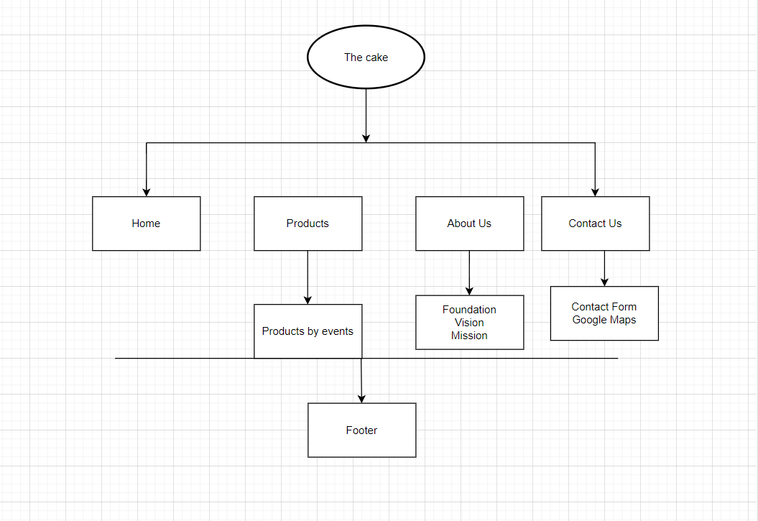

**SCREENSHOT**

* Navigation menu

# 

* Home

# 

* Products page

# 

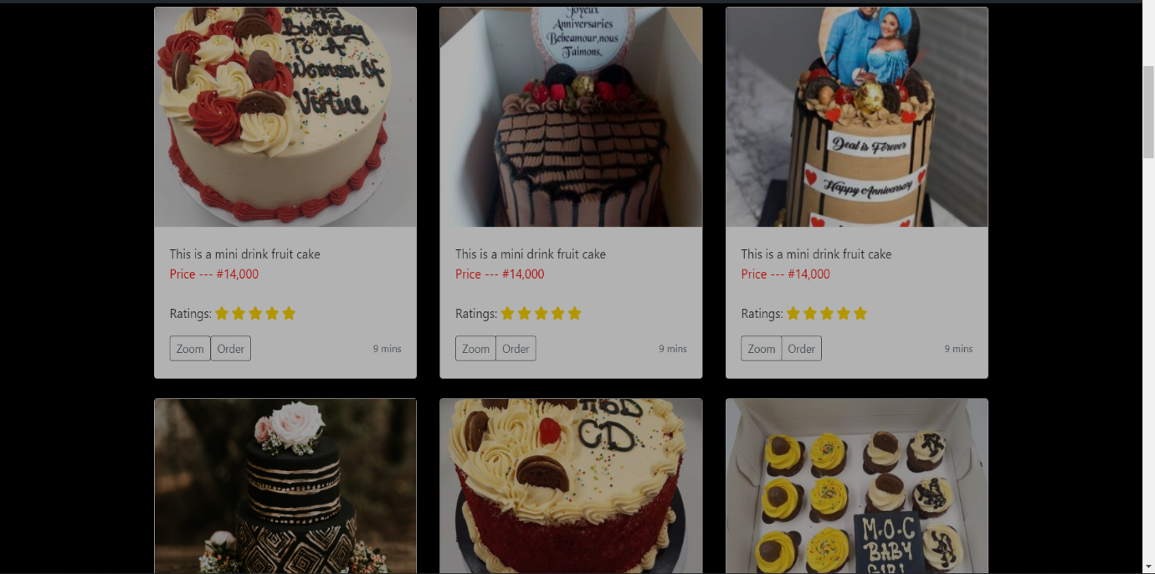

* Google map

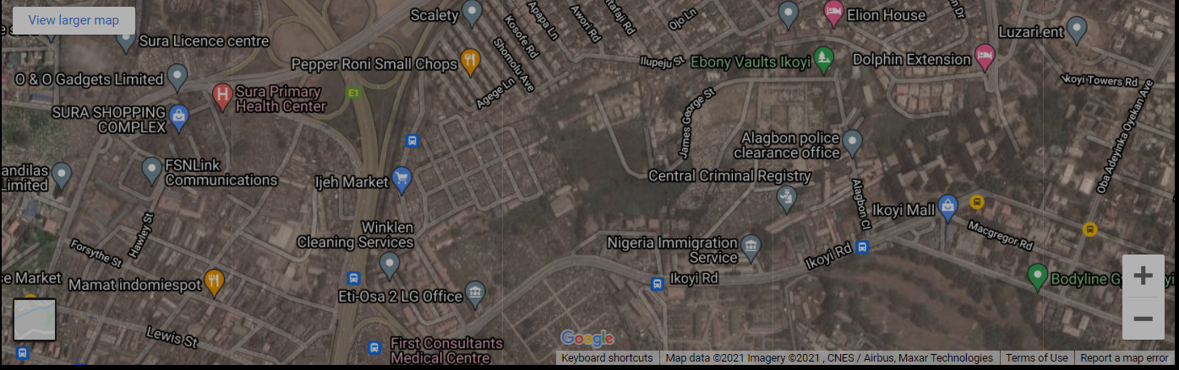

* Contact form

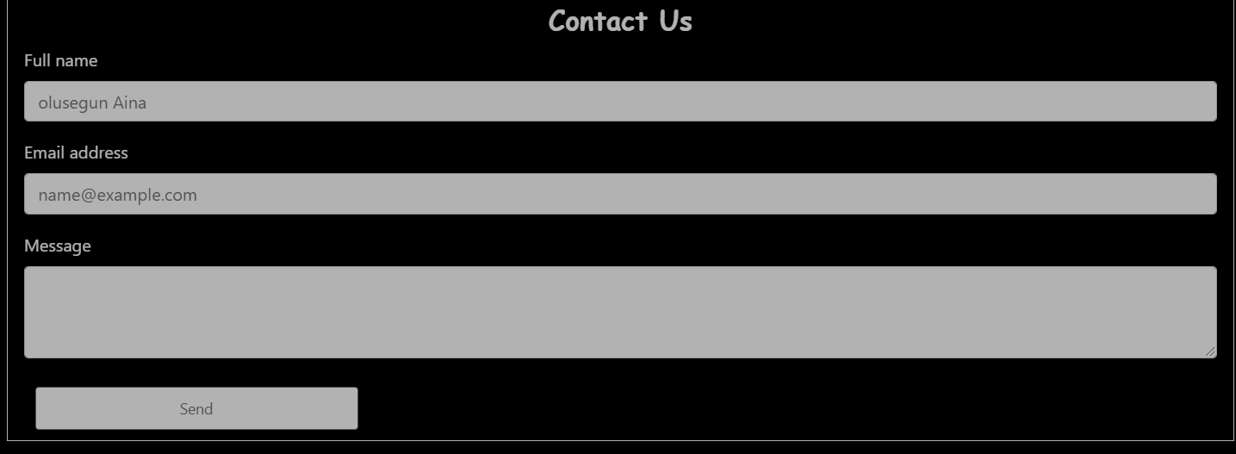

# 

* Footer

# 

# 

# 

**USER REQUIREMENTS**

* ­ SYSTEM REQUIREMENTS
* Operating system: Windows 7 or higher OS
* Software: HTML 5 or JavaScript supporting browsers